Data Cleaner

Requirements / Desire Behavior
Implement an easy and flexible way to handle data cleaning / scrubbing of data within a database instance.

Technology / Language
Microsoft SQL Server – SQL (TSQL)

Execution Method
Single File Script Execution Run using Microsoft SQL Management Studio (or equivalent) with the target database instance connected.

High level diagram to illustrate the objects involved and what can be applied to them.
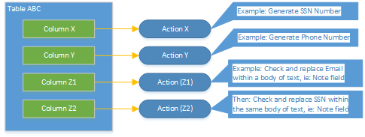
- Application will consists of a single folder of SQL scripts with one main script for execution.
- Initially, there will be external scripts to be used for the “Actions” that can be applied to a table column. This is to make development easier for this phase of the implementation.
- The main script file will be composed of the following major sections:
  - Variable to control the path / location of the script files relative to the local file system
  - (Optional) Ability to remove existing Data Clean tables
  - Check and create Data Clean tables and default data if they do not exists in the target database instance
  - (Optional) Ability to display out the configured Data Clean data
  - Run the table cleaning (truncate / reseed) prior to the cleaning / scrubbing process
- Actions
  - Unique functionality that can be applied to a specific table column.
  - Each action will correspond to a unique SQL file (for this initial phase of the project) and this file is referenced in the Data Clean Action table.
  - Multiple actions can be applied to a specific table column in a specific order.
  - Examples of some actions that can be implemented:
    - Direct text replacement – replace every row in the specified table column with a replacement value
    - Direct text replacement non nulls – replaces only the rows in the specified table column that has a value with the replacement value
    - Relative Replace – Replaces the specific table column data at row x with one from another row randomly where it does not match the value at row x.
    - Email partial – replaces the first part of an email with a generated alphanumeric value keeping the rest of the email on rows that have valid email addresses. Example: john.doe@abc.com => 23FKSA@abc.com
    - Email Generate – Generate a full fake email for the specified table column.
    - Phone (Formatted) Generate – Generate a formatted phone number for the specified table column. Example of formatted phone number: (716) 123-3456
    - SSN Generate – Generate a fake formatted SSN number
    - SSN PartialMask – Replace existing SSN numbers by masking the first 5 digits, leaving the last 4 digits.
    - 16 or (n) Alpha Numeric Generate – generate a text string of 16 or (n) for the specified table column.
    - SSN SearchReplace – Search for all SSN numbers that exists in a text (note) field and generate a fake SSN as a replacement.
    - Email SearchReplace – Search for all valid emails that exists in a text (note) field and generate a fake email as a replacement
    - Phone SearchReplace – Search for all valid formatted phone numbers in a text (note) field and generate a fake phone as a replacement.
    - ….etc.

High level design and flow diagram
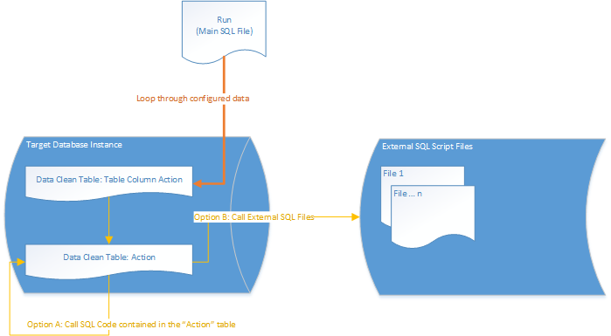

Database Tables
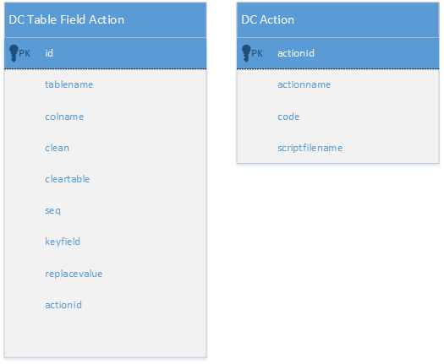
Data Clean Table Field Action (DCTableFieldAction)
- Table Name (tablename)
- Column Name (colname)
- Clean (clean) – Indicates whether or not the data row will be executed in the data clean process.
- Clear Table (cleartable) – Indicates whether the associated table should be cleared (truncated) and have its identity column reseeded (if one exists).
- Sequence (seq) – Controls the order of the execution
- Key Field (keyfield) – Optional field for action scripts that require a key field
- Replacement Value (replacevalue) – optional field. Used when the action field requires a specific replacement value
- Action ID (actionid) – Foreign key referencing the “Action” to be used.
Data Clean Action (DCAction)
- Action Name (actionname)
- Code (code) – Holds the SQL script(s) to be executed when the action is used.
- Script File Name (scriptfilename) – Holds the SQL script file name to be referenced and used when the action is used.

